Text Party

Software Requirements Specification (SRS)

Team Members:
Robert Chandler
Josh Holt
Mason Salisbury
Brian Nicolas
Revision History

Date | Revision | Description | Author
10/23/17 | 1.0 | Initial Version | Mason Salisbury
10/25/17 | 2.0 | Introduce Main and Controllers | Robert Chandler
10/27/17 | 3.0 | Include load and save history | Robert Chandler
10/30/17 | 4.0 | Includes increased comments and documentation | Robert Chandler
11/1/17 | 5.0 | Clean up potential test files | Robert Chandler
11/13/17 | 6.0 | Improves functionality | Robert Chandler
11/24/17 | 7.0 | Final Documentation added | Brian Nicolas
11/27/17 | 8.0 | Final Deliverable | All

Table of Contents

- Project Overview 1
  - Overview 1
- Use Cases 2
  - Use Case Diagram 2
  - Use Case Scenarios 2
- Test Plan 3
  - Test Cases 3
- Project Plan 4
  - Plan for the First Deliverable 4
  - Plan for the Second Deliverable 4
  - Plan for the Third Deliverable 4

Project Overview

Overview
The software is designed to take one or more files as input and output information about those files. Specifically, it will report word count information including but not limited to number of words, lines, and blank lines. The software will further provide help on how to proceed and remove punctuation for the analysis. Lastly, the software will be able to report the history of all files processed as well as represent data for those files.

Use Cases

Use Case Diagram
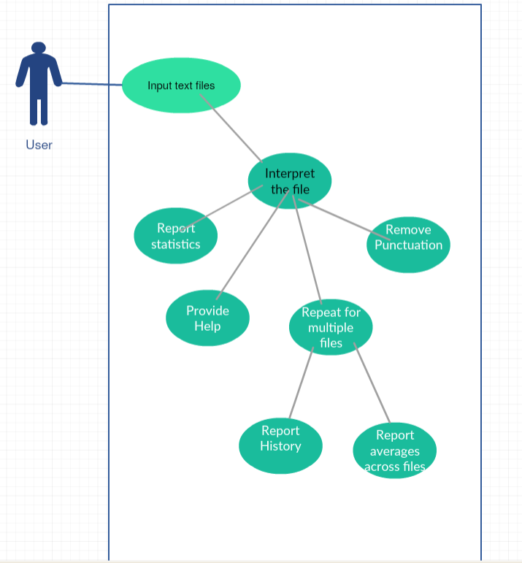

Use Case Scenarios
Provide a list of use case scenarios of this software product.
As a user I need help using the app because I don’t know how to use the app.
As a user I need a Graphical User Interface because it will make working with the application easier.
As a user I need to be able to open and validate file names because it is necessary to keep track of each file.
As a user I need to read files from text, and report on their statistics because I need to do that for my job.
As a user I need to be able to remove punctuation and possession from these files because it is necessary for my job.
As a user I need to be able to handle multiple files at once because it will allow me to complete my job much faster.

Test Plan

Test Cases
Specify required behavior of the software product and include parameters such as possible input, expected output, on error, etc.

 | Feature | Description | Possible Input | Expected Output
1 | Upload File | Run the program and output descriptions about the text file. | Text File | Output statistics
2 | Report on multiple files | Allow for multiple files to be run and report the history | Text File | Output statistics

Project Plan

Plan for the First Deliverable

 | Task | Description | Assignment
1 | Class Diagram | Class Diagram of the project will be drawn. | Brian
2 | GUI Panel | Development of GUI Panel using JavaFX API in Eclipse. | Robert, Mason
3 | Basic functionality | Program should provide most outlined functions | Robert, Mason, Josh
4 | Documentation | Provide documentation about program | Brian

Plan for the Second Deliverable
 | Task | Description | Assignment
1 | Add functionality | Add more features such as history of files | Robert, Mason, Josh
2 | Documentation, Use Case, and Class Diagrams | Include all documentation and files regarding the progress of the project | Brian
3 | Improve GUI | Improve user interface | Robert

Plan for the Third Deliverable

 | Task | Description | Assignment
1 | Refine program | Work out any bugs and clean up GUI | Mason, Josh
2 | Finish Documentation | Finish all documentation regarding the project | Brian

